Photographer & Graphic Artist
Memberships: Skagit Artists – 2008-2014 & 2022 – Present & Allied Arts – 2004 - Present
Selected Shows: Allied Arts Holiday Festival – Dec 2016 - Present
PNW Art Market – Apr – 2021 - Present
Art In a Pickle Barn – Apr 2005 – 2018
Tulip Valley Wine & Art Show – 2010 – 2020
Selected Awards: September 2020 – People’s Choice Award – Jansen Art Center, Lynden WA
April 2018 – Multiple Awards – Art In a Pickle Barn – Tulip Festival
Mar 2018 & Sep 2020– Honorable Mention –NW Council of Camera Clubs
October 2017 – Tulip Secret Window – 2nd Place AAC Fall Into Art
April 2017 - Best Tulip Award and multiple other awards – Tulip Festival
November 2016 – Creative Award – NW Council of Camera Clubs
April 2016 – Honorable Mention – Tulip Town – Burlington Art Walk
April 2014 – Honorable Mention – Laburnum Walk – Burlington Art Walk
April 2013 – Best of Show- Wagon Wheel Tulips – Burlington Art Walk
April 2011 – 2nd Place Overall and multiple awards – Art In a Pickle Barn
April 2010 – Best Tulip Award – Art In a Pickle Barn Tulip Festival
Feb 2009 - People’s Choice - Wildlife Best Picture - Eagle Festival
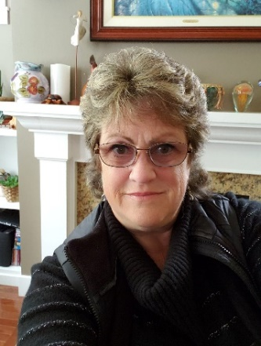
Louise Magno
Natural Moments Studio, LLC

Photography is my first love. Wildlife, Flowers, and Landscapes, are my favorite subjects, but architecture also intrigues me. I am always looking for a unique perspective & try to share it with all who see my work. My goal is to capture moments in time with my work. I teach occasionally at the Allied Arts Gallery as well as other locations. My passions are God, photography, gardening, traveling & family. I make my home in the Great North West
Unplug from life & take a journey with me through my moments in time
Do you NEED a different size on a Fine Art Piece?? Please contact me and I can publish any of my pieces to a different (smaller/much larger) canvas size and have it shipped directly to your home for $8.95 (canvas only - regardless of size) OR in metal (shipping TBD).
360-708-3170 EMAIL - info@NaturalMomentsStudio.com
My work is hanging in businesses such as; Skagit Valley Hospital, United General Hospital, Mira Vista, & private homes throughout the US, and Canada. I have been published in multiple publications and show at several shows throughout the year in WA & Western States. My work is available & sells through an On-line Gallery - Fine Art America @ http://louise-magno.pixels.com/ I have a store on Amazon @ https://www.amazon.com/dp/B018FO8AGI/ref=hnd_dp_smp_text My web site has more information about me, my products and a list of where I am currently showing www.naturalmomentsstudio.com
I am part of social networking on https://www.facebook.com/NaturalMomentsStudio OR https://www.instagram.com/louise.magno/

